EXERCISE 1 (BUFFERS)

Introduction
Bronsted buffers are mixtures of weak acids and their soluble salts which resist changes in pH upon addition of a highly ionized acid or base. Many biological molecules and systems such as enzymes, nucleic acids, and membranes are very sensitive to changes in the concentration of hydrogen ions. Thus, the regulation of pH by buffers in cells and body fluids is very important to normal cell function. For example, the pH of the blood in most mammals must be maintained between 7.3 and 7.5. Indeed, there are several effective buffer systems present in mammalian blood. For analogous reasons, laboratory studies with enzymes and other biomolecules require buffers.

With weak acids and bases, proton addition or donation is influenced by the pH of the medium. The ionization of weak acids follows the Henderson-Hasselbalch equation:

pH = pKa + log [Base]/[Acid]

Where: [Base] = Base form (or salt of acid form) of acid/base pair
[Acid] = Acid form of acid/base pair
pH = -log [H⁺]
pKa = -log Ka

The pKa is the negative log of the ionization constant for the Bronsted acid. Examination of the Henderson-Hasselbalch equation leads to further understanding of the term pKa. When the ratio of the concentration of the acid to its conjugate base equals one, the log expression equals zero; thus, pKa can be defined as the pH at which the concentration of the acid and base forms are equal. The pKa also equals the pH at which the buffer system is most effective against both added acids and bases.

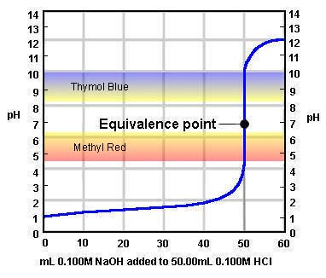
Titration curves are useful for providing information about the pKa values of Bronsted acids, as the pH inflection point of the titration curves is numerically equal to the pKa of the titrated acid. If the pKa is known for a particular acid, the Henderson-Hasselbalch equation may be used to estimate the relative amounts of acid and its conjugate base that must be added to water to prepare a buffer at a desired pH. Titration curves for some representative weak acids are shown on the next page.

Figure 1-1. A graph representing the titration of a strong acid with a strong base. Note that the strong acid is not able to resist changes in ph and near neutrality there is a very large change in pH with a small addition of NaOH.

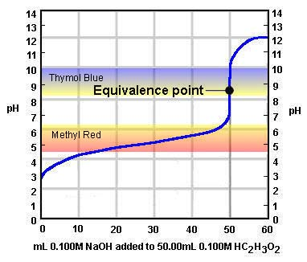
Figure 1-2. A graph representing the titration of a weak acid with a strong base. Note that the weak acid does not have the same change in pH over the same additions of NaOH as the strong acid in Figure 1.1.

______________________________________________________________
Table 1-1. pKa values for some acid components of common biological buffers.
________________________________________________________________________

Name pKa Name pKa
________________________________________________________________________

Phosphoric acid 2.12 (pKa1) MOPS 7.20
Citric acid 3.06 (pKa1) Phosphoric acid 6.91 (pKa2)
Formic acid 3.75 TES 7.50
Succinic acid 3.06 (pKa1) HEPES 7.55
Citric acid 4.74 (pKa2) HEPPS 8.00
Acetic acid 4.76 Tricine 8.15
Citric acid 5.40 (pKa3) Glycine amide (HCl) 8.20
Succinic acid 5.57 (pKa2) Tris 8.30
MES 6.15 Bicine 8.35
ADA 6.60 Glycylglycine 8.40
Bis-Tris Propane 6.80 Boric acid 9.24
PIPES 6.80 CHES 9.50
Imidazole 7.00 Phosphoric acid 12.32 (pKa3)
________________________________________________________________________

Objectives
The objectives of this laboratory exercise are the following: 1) To prepare stock solutions of Bronsted acids and bases, 2) to examine the buffering capacity of water, a weak acid and a buffer, and 3) to prepare a phosphate buffer of desired pH.

Materials and Methods
Materials

The following materials will be required: NaOH pellets, concentrated HCl, glacial acetic acid, solid sodium acetate, Na- or K-acetate (mono-, di- and tri-basic forms), burettes, burette holders and ring stands, pH meter, pH standard solutions (pH 7 and pH 10), magnetic stir plate and magnetic stir bar.

Methods

Preparation of NaOH and HCl Solutions

Prepare 100 mL of 2 N NaOH. First determine the formula weight (usually listed on the reagent bottle) and calculate the number of grams of solid NaOH which must be dissolved in H₂O. Add less than the final volume of H₂O (for example 60-70 mL) to NaOH pellets in a beaker. After the NaOH pellets are completely dissolved transfer to a 100 mL volumetric flask or a graduated cylinder and add H₂O to bring the final volume of solution to 100 mL.

Prepare 100 mL of 2 N HCl. You must dilute the concentrated HCl solution (usually about 11.6 N) to the final concentration of 2 N. Use the dilution formula and calculate the number of mL of concentrated HCl which must be diluted to give 100 mL of 2 N solution. Working in the hood, measure the desired number of mL using a 10 mL glass pipet or a 10 mL graduate cylinder and add to approximately 50 mL of H₂O in a small beaker. Next, transfer to a 100 mL volumetric flask or a graduated cylinder and add H₂O to bring the final volume of solution to 100 mL.

Titration of H₂O, Acetic Acid and Acetate Buffer

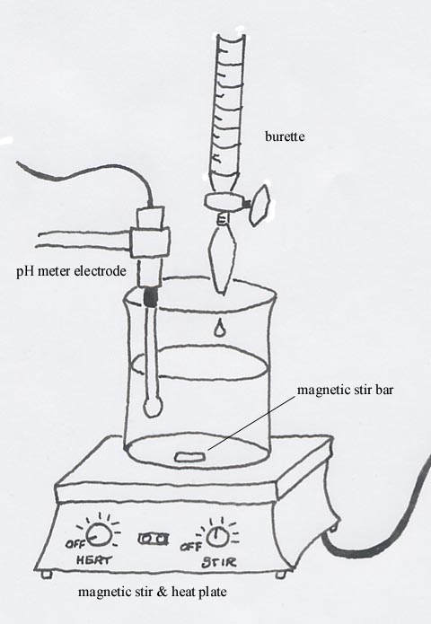
Familiarize yourself with the operation of the pH meter and standardize the instrument (use pH 7 standard buffer). The pH meter measures the hydrogen ion concentrations (actually activity) of a solution by exchanging ions at the tip of the glass electrode. This electrode is a very delicate glass tube that contains saturated salt solutions and thin electrical leads. The tip is a gel-coated glass membrane, and it must be handled properly to avoid damage. The electrode should always be suspended in aqueous solution, either water, buffer or test solution. To use the pH meter, lift the electrode out of the holding solution; the meter should be in the standby or hold position. Spray with electrode tip with a stream of water using a water wash bottle; then gently blot it with a lab wipe. Place the electrode in the solution being tested. Turn the meter to read the pH (with your meter the instrument is operational when the standby button is pushed to release it and projects outward). When you are finished, return the meter to standby position and repeat the rinsing procedure.

Set up the burettes. Using your marker pen, label one burette HCl and the other NaOH. First, fill one burette with the appropriate 2 N solution (the ones you prepared) and attach to the ring stand via the burette holder. Next fill and attach the second burette. Set up the electrode, stirring bar, magnetic stirrer and burette as shown in Fig. 2, so that the sample can by titrated with continuous stirring. Remember: The glass electrode is rather fragile; place the electrode to the side of the beaker to prevent the stir bar from continuously striking and damaging the electrode.
Figure 1-3. A diagram of the titration set-up for this exercise.
Titrate the pure H₂O. To begin the titration study, place 30 mL of H₂O in a 100 mL beaker. Now, titrate the sample with 2 N HCl one drop at a time for the first few drops, approximately 3 drops at a time for the next few drops and about 5 drops at time thereafter until the pH reaches 2.5. Record the volume of acid used (this may be read off the graduated scale of the burette) and the pH after every set of drops. When the HCl titration of H₂O is complete, obtain a fresh 30 mL of H₂O and carry out a titration with 2 N NaOH. Use a similar procedure to that employed with HCl, except in this case follow an increase in pH until it reaches 11.5. Note: Do not be surprised if the pH changes very dramatically when you begin the titration.

Titrate 0.25 M acetate buffer. Obtain 2 samples (30 mL each) of acetate buffer from your instructor. Titrate one sample with 2 N HCl and the other sample with NaOH as described above. Again, record changes in pH and the volume of HCl or NaOH used. Note: Do not be surprised if the pH changes much less rapidly compared to the H₂O titration.

Titrate 0.25 M acetic acid solution. Obtain 1 sample (30 mL) of acetic acid solution from your instructor and carry out NaOH titration as described. Note: If the pH of a solution is 10.0 or more, no additional titration is necessary.

Plot the data from the titration experiment. As in all cases, the independent variable goes on the abscissa or x-axis and the dependent variable goes on the ordinate of y-axis. Thus, the volume of HCl or NaOH used should be plotted on the x-axis and the measured pH should be plotted on the y-axis. Discuss the significance of the results with regard to buffering range and the selection of buffers.

Preparation of Phosphate Buffer

Using the Henderson-Hasselbalch equation and pKa values listed in Table 1, calculate the amount of acid and conjugate base that one must use to prepare 50 mL of 50 mM phosphate buffer at pH 7.0. Obtain Na phosphate (mono- and dibasic, i.e., NaH₂PO₄ and Na₂HPO₄) from you instructor and prepare 50 mL of buffer. Remember, the formula weights should be listed on the reagent bottle for each. After calibrating the pH meter to pH 7, determine the pH of your phosphate buffer. Then dilute your buffer with 30 mL of water, disturb your buffer and measure the pH again. Expect what will happen and explain why. Discuss buffer preparation and agreement between the calculated and the measured pH values.

